IT24101780

Wanigasekara Y.A.

Lab - 07

Probability and Statistics

Exercise

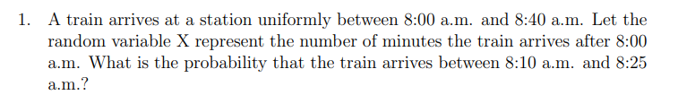

Answer





Answer



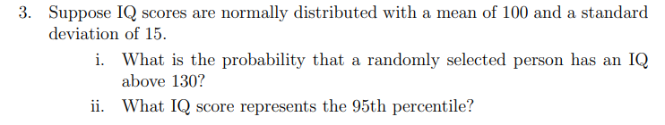

Answer

